Lab Practical #01:
Study of basic networking commands and IP configuration.
Practical Assignment #01:
- Perform and explain various networking commands listed below:
  - ipconfig
  - ping
  - getmac
  - systeminfo
  - hostname

ipconfig

Description:
Ipconfig (Internet Protocol Configuration) is a command-line tool used in Windows and other operating systems to display a device's current network settings.
No. | Option | Description
1 | Ipconfig / all | The ipconfig /all is a command used in Windows to display detailed network information.
2 | Ipconfig / release | The ipconfig /release command forces your computer to immediately give up its current IP address.
3 | Ipconfig / renew | The ipconfig /renew command tells your computer to ask your router for a fresh IP address
4 | ipconfig | The ipconfig (Internet Protocol Configuration) command is a tool used in the Windows Command Prompt to view your computer's current network details and troubleshoot connection issues.
5

Implementation:
Ipconfig:
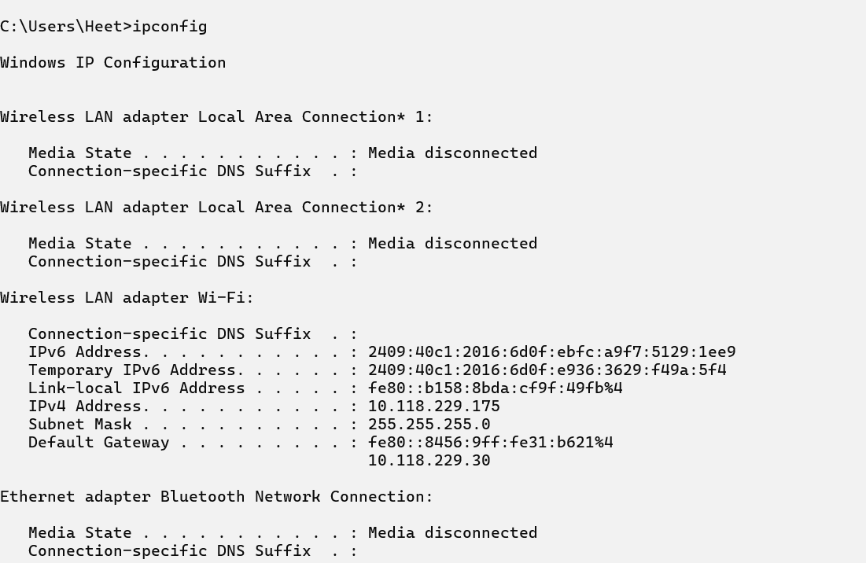
Ipconfig / all:
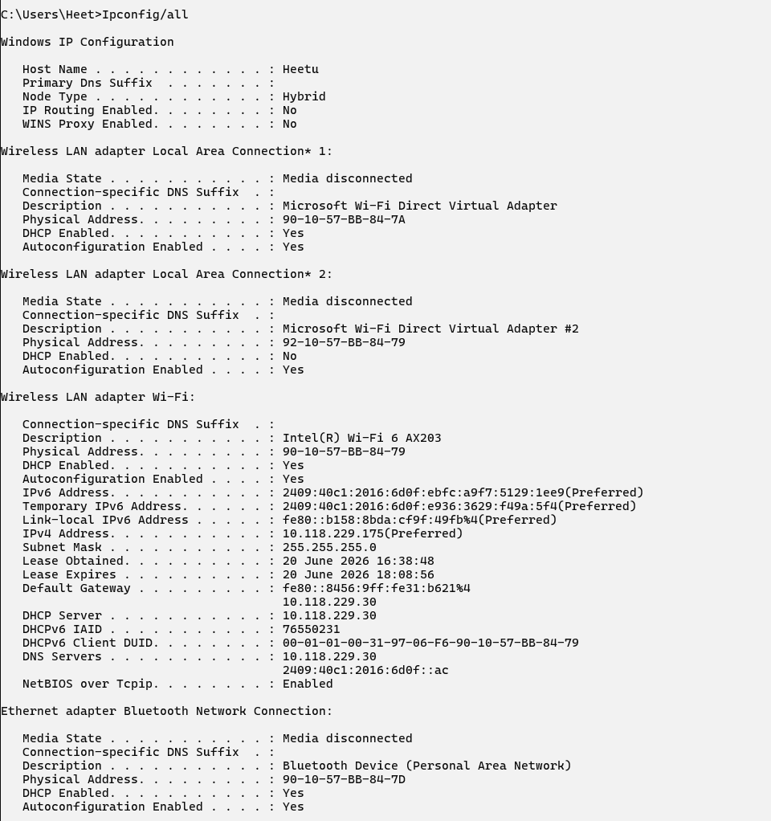
Ipconfig / release:
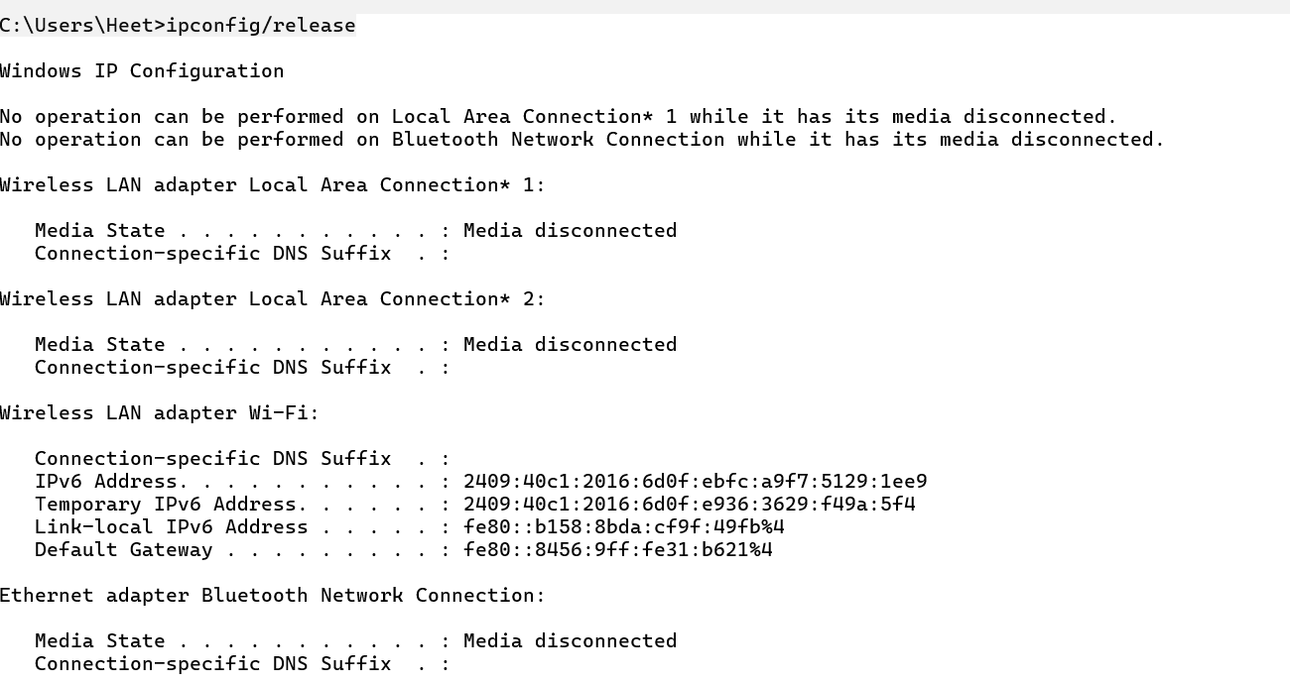
Ipconfig / renew:
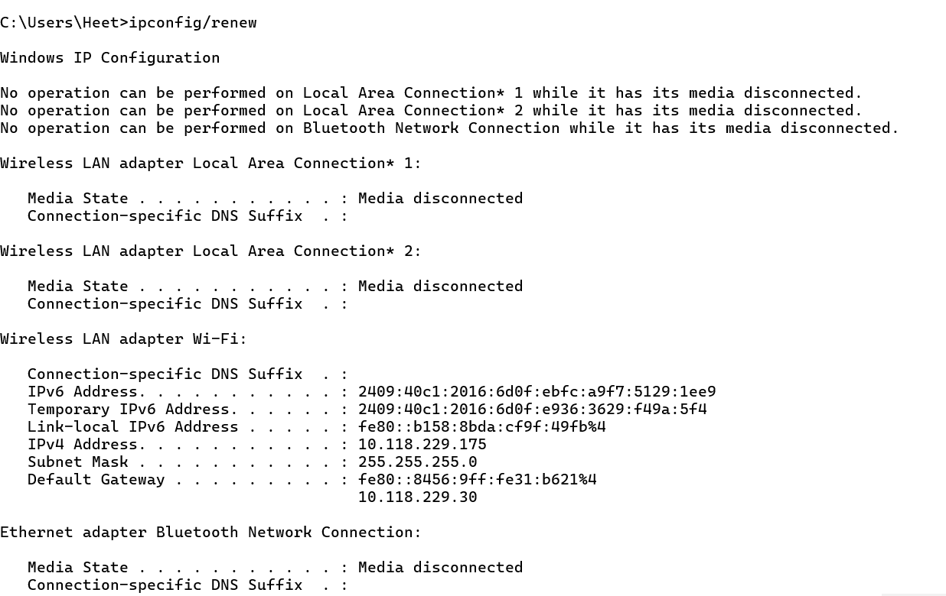

ping

Description:
Ping (Packet Internet Groper) is a network utility used to test if a device is reachable over an IP network
No. | Option | Description
1 | Ping (host) | Ping is a command line tool used to test if a computer or server is connected to the network and active.
2 | Ping / t (host) | The ping -t command continuously tests network connectivity to a specific destination (host) until must be manually stopped using CTRL+C
3 | Ping / n (count) (host) | The ping -n command tests the connection between your computer and a website or server by sending a specific number of test signals (packets).
4 | Ping / l (size) (host) | The ping -l command tests your network connection by sending a custom-sized packet of data to a specific website or device.
5

Implementation:
Ping (host):
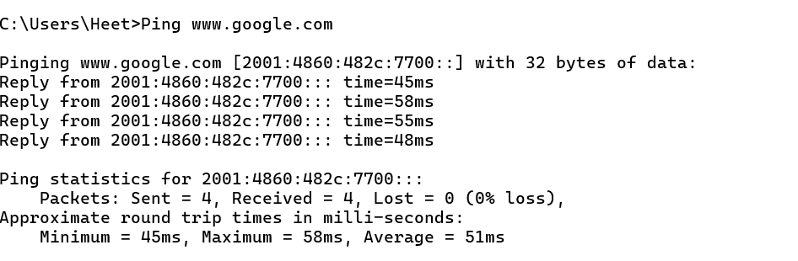
Ping /t (host):
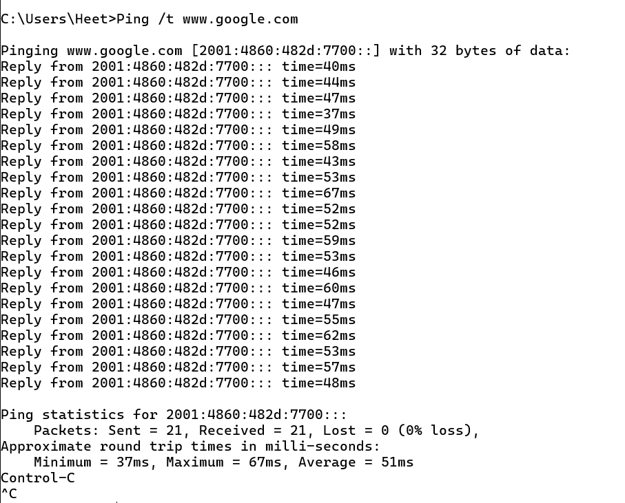
Ping /n (count) (host):
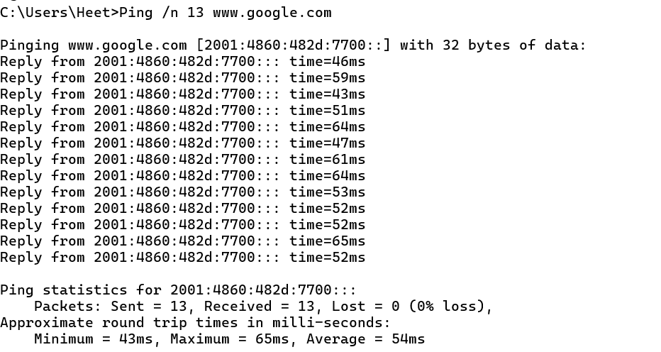
Ping / l (size) (host):
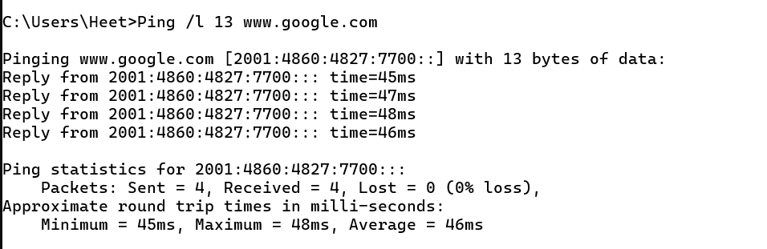
Getmac:
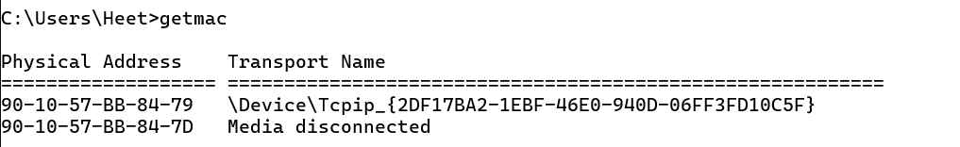

Systeminfo:
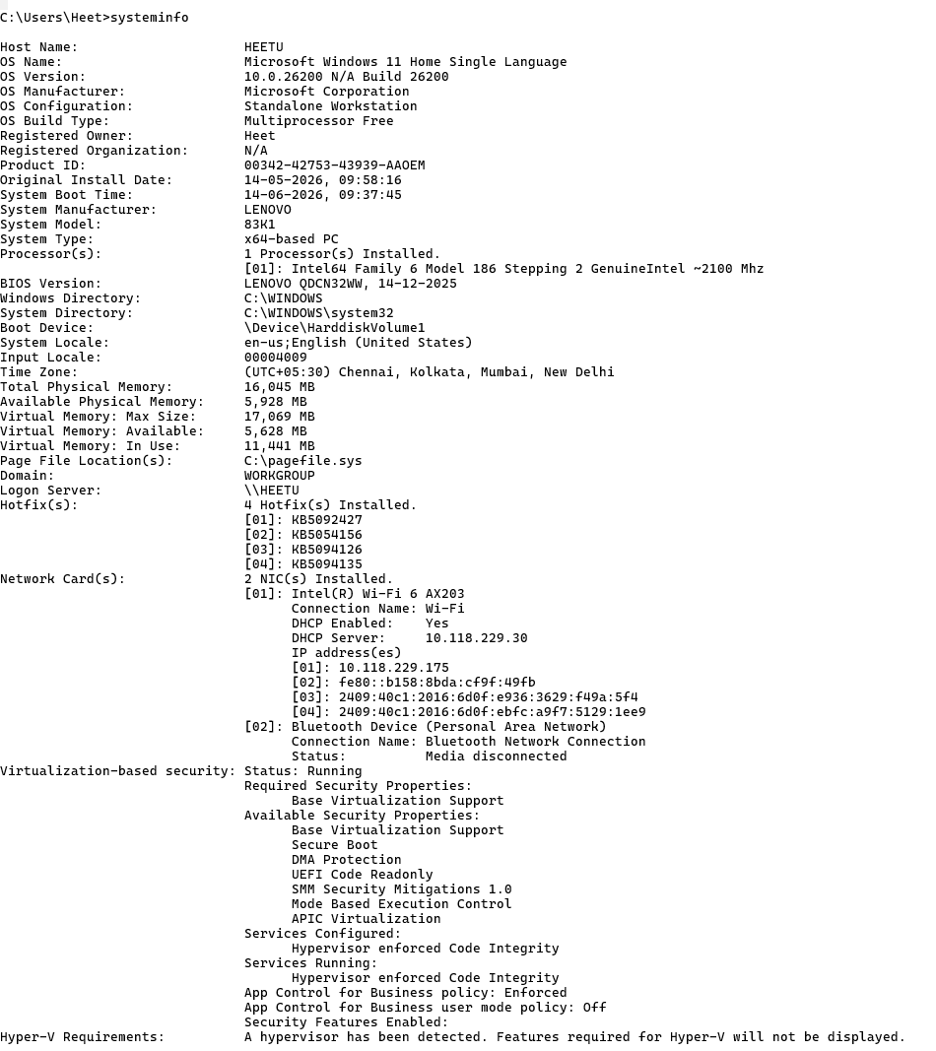

Hostname:


